Response to change

Template

Please complete this section of the template before doing the research.

Step 1:

Think of two change experiences you have recently experienced and on the template provided, provide an overview of what the change was.

1. A change imposed upon you – where you felt like you didn’t have a choice in the change. It can a be a small or large change; gradual or sudden; expected or unexpected.
2. An intentional change where it was a conscious decision by you to initiate or support a change.

|  |
| --- |
| Change that was imposed on me: In my 2nd semester in my college, I was in the Rotaract club, and this was the place where I contribute, put my hand forth for the development and the well-being of society accordingly. It was the way by which I feel motivated. Being a youth it's our responsibility to do whatever we can do for the upliftment of lower strata of the society not by money and promises only but your time and helping hands too. But as time goes and I started to work for technical department of my college on behalf of IIT-KHARAGPUR as a collage ambassador both works were nice but I was lagging at some point because helping others provides internal pleasure to me. |
| Change that was intentionally generated by me: I was interested in ECE when I passed my second semester and try to manage anyhow to get ECE branch at my collage since then I was not very much familiar about my CSE department but as time passed I got to know that CSE is very interesting and changed my mind and plans. |

Step 2:

Think about and record the range of reactions you experienced (mindset/emotions and behavior) as you went through the changes – from the beginning to the end.

|  |
| --- |
| The range of reactions experienced for the change that was imposed on me was:Most modern industrial societies value the person who is willing and able to initiate and respond positively to change, and yet,organizations that attempt to initiate such changes are often stymied by individuals or groups within the organization who resist the changes. Often the reasons for the resistance are not far to seek:The benefits to the organization are not necessarily consonant with—and are often antithetical to—the interests of the individuals being asked to make the change   1. Reluctance to lose control 2. Cognitive rigidity 3. Lack of psychological resilience. 4. Intolerance to the adjustment period involved in change. 5. Reluctance to give up old habits. 6. Reluctance to give up old habits. |
| The range of reactions experienced for the changed that I intentionally generated was: Building the Resistance to Change Scale Method, Personality Correlates of the Resistance to Change Scale and a Reconfirmation of its Structure, Validating the Resistance to Change Scale’s Structure, Resistance to Change and Cognitive Ability Method. |

Step 3:

Complete the reading and research in the additional resources to get a better understanding of ‘why’ you experienced what you did and then complete the next page.

Step 4:

Now that you’ve done your research about the Change Curve, please complete the final section. Here is a reminder of the Change Curve:

The Kübler-Ross change curve

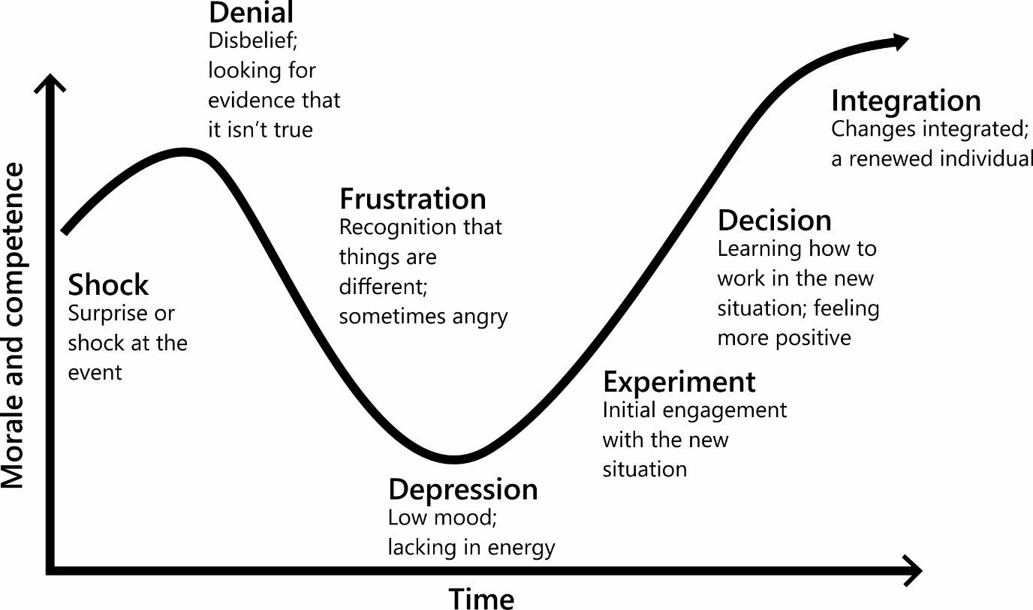

Step 5:

Identify what you have learnt from reflecting on this experience. Thinking back to the changes you wrote about earlier, identify what you have learnt from reflecting on this experience. It would also be beneficial to detail what happened at each stage of the Change Curve for you.

|  |
| --- |
| My reflections and learnings for the change that was imposed on me: 1. Reflection requires active engagement on the part of the individual: Most of the reflection in the learning journals was triggered by sessions during which the students had been particularly active. In particular, group work, discussion and debate and personal or group presentations seemed to stimulate reflection. Sometimes I was clearly thinking about themselves as learners and what was effective for them, for example: ‘I cannot stress enough how actively participating in seminar group discussions has helped me to cement the ideas delivered in a lecture.’  Often they were thinking about how they functioned within the group:  This sparked a huge debate among our group […] A very telling experiment and a lot came from it. I realized that my part was one of the gatekeeper, drawing everyone into the discussion, even the quieter members. Reflection is triggered by unusual or perplexing situations or experience: Throughout the learning journals there was considerable evidence that was reflecting well under circumstances which were familiar and comfortable. However, ‘perplexing’ situations clearly also triggered substantial reflective writing, for example, I observed:  that when I tried to put my point across I was ignored. I think it was mostly because of my age. I was in a group of mature students, and they didn’t seem to think I knew what I was talking about. |
| My reflections and learnings for that change that I intentionally generated:However, it was far more usual for ME to reflect on their emotional (rather than intellectual) responses, beliefs and premises, for example, I noted: ‘At the beginning of the year I thought that I was going to be left behind, but now I think that I am someone different because I am discovering myself.’ Another echoed similar sentiments: ‘I feel a lot more positive now, knowing that I am as capable as everyone else that is on the course, and also with the knowledge that I earned the right to be here!’ |

Any final thoughts or reflections on how you could deal with change more effectively in the future?

**Valuing Reflection:** Teachers who promote reflective classrooms ensure that students are fully engaged in the process of making meaning. They organize instruction so that students are the producers, not just the consumers, of knowledge. To best guide children in the habits of reflection, these teachers approach their role as that of "facilitator of meaning making."

In the role of facilitator, the teacher acts as an intermediary between the learner and the learning, guiding each student to approach the learning activity in a strategic way. The teacher helps each student monitor individual progress, construct meaning from the content learned *and* from the process of learning it, and apply the learnings to other contexts and settings. Learning becomes a continual process of *engaging* the mind that *transforms* the mind.

Unfortunately, educators don't often ask students to reflect on their learning. Thus, when students *are* asked to reflect on an assignment, they are caught in a dilemma: "What am I supposed to do? How do I 'reflect'? I've already completed this assignment! Why do I have to think about it anymore?"

In response to our questions, students who are inexperienced with reflection offer simple answers such as "This was an easy assignment!" or "I really enjoyed doing this assignment." If we want students to get in the habit of reflecting deeply on their work—and if we want them to use Habits of Mind such as applying past knowledge to new situations, thinking about thinking (metacognition), and remaining open to continuous learning—we must teach them strategies to derive rich meaning from their experiences.

## Setting the Tone for Reflection

Most classrooms can be categorized in one of two ways: active and a bit noisy, with students engaged in hands-on work; or teacher oriented, with students paying attention to a presentation or quietly working on individual tasks. Each of these teaching environments sets a tone and an expectation. For example, when students work actively in groups, we ask them to use their "six-inch" voices. When we ask them to attend to the teacher, we also request that they turn their "eyes front." When they work individually at their desks, we ask them not to bother other learners.

Teachers must signal a shift in tone when they ask students to reflect on their learning. Reflective teachers help students understand that the students will now look back rather than move forward. They will take a break from what they have been doing, step away from their work, and ask themselves, "What have I (or we) learned from doing this activity?" Some teachers use music to signal the change in thinking. Others ask for silent thinking before students write about a lesson, an assignment, or other classroom task.

In the reflective classroom, teachers invite students to make meaning from their experiences overtly in written and oral form. They take the time to invite students to reflect on their learnings, to compare intended with actual outcomes, to evaluate their metacognitive strategies, to analyze and draw causal relationships, and to synthesize meanings and apply their learnings to new and novel situations. Students know they will not "fail" or make a "mistake," as those terms are generally defined. Instead, reflective students know they can produce personal insight and learn from *all* their experiences.